**DBMS LAB 8 – Functions and Procedures**

By: Ishita Bharadwaj

SRN: PES1UG20CS648

Section: K

Roll No: 43

Q 1) Functions

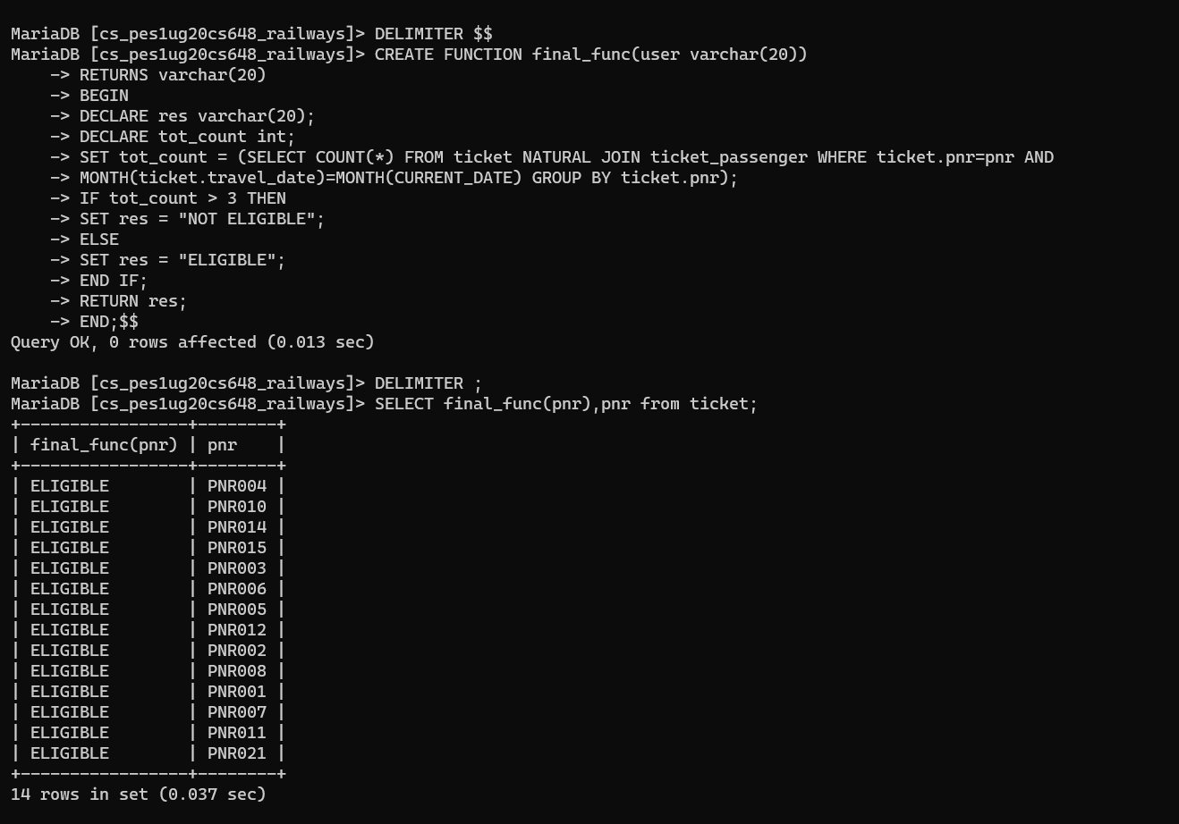

Q 2) Procedure

